Advocacy support
- POhWER support centre can be contacted via 0300 456 2370
- Advocacy People gives advocacy support on 0330 440 9000
- Age UK on 0800 055 6112
- Local Council can give advice on local advocacy services

Further action

If you are dissatisfied with the outcome of your complaint from either NHS England or this organisation, then you can escalate your complaint to Parliamentary Health Service Ombudsman (PHSO) at either:
Milbank Tower
Milbank
London
SW1P 4QP

or

Citygate
Mosley Street
Manchester
M2 3HQ

Tel: 0345 015 4033
www.ombudsman.org.uk

Wallingbrook Health Group
Back Lane
Chulmleigh, Devon EX18 7DL
Telephone: 01769 580295

The

Complaints

Process
  - Wallingbrook Health Group
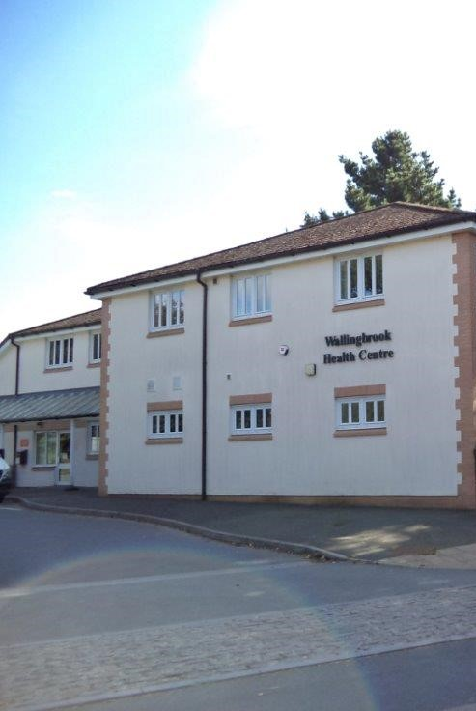

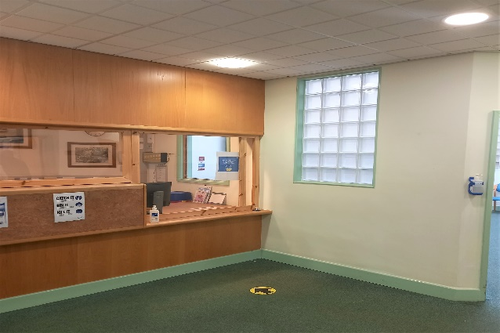

Talk to us
Every patient has the right to make a complaint about the treatment or care they have received at Wallingbrook Health Group.
We understand that we may not always get everything right and, by telling us about the problem you have encountered, we will be able to improve our services and patient experience.
Who to talk to
Most complaints can be resolved at a local level. Please speak to a member of staff if you have a complaint; our staff are trained to handle complaints.
Alternatively, ask to speak to the Complaint Manager, Lucy Harris, Managing Partner. If for any reason you do not want to speak to a member of our staff, you can make a complaint about the services to NHS Devon.
NHS Devon Contact Details
Telephone: 0300 123 1672
Email: d-icb.patientexperience@nhs.net
Post: Patient Advice and Complaints team, Pomona House, Edginswell Business Park, Oak View Close Torquay TQ2 7FF
Contact information:
Can also be found on the One Devon website:
www.onedevon.org.uk/contact-us/patient-advice-and-complaints/
A complaint can be made verbally or in writing. A complaints form is available from reception.
Time frames for complaints
The time constraint on bringing a complaint is 12 months from the occurrence giving rise to the complaint, or 12 months from the time you become aware of the matter about which you wish to complain.
The complaints manager will respond to all complaints within three business days. We will aim to investigate and provide you with the findings as soon as we can and will provide regular updates regarding the investigation of your complaint.
Investigating complaints
Wallingbrook Health Group will investigate all complaints effectively and in conjunction with extant legislation and guidance.
Confidentiality
Wallingbrook Health Group will ensure that all complaints are investigated with the utmost confidentiality and that any documents are held separately from the patient’s healthcare record.
Third party complaints
Wallingbrook Health Group allows a third party to make a complaint on behalf of a patient. The patient must provide consent for them to do so. A third-party patient complaint form is available from reception.
Final response
Wallingbrook Health Group will issue a final formal response to all complainants which will provide full details and the outcome of the complaint. Further information is detailed in our organisation policy.

