PATIENT PARTICIPATION GROUP – MINUTES
Thursday 23 July 2020 via Zoom

Present: Jack Earnshaw (JE), Sue Ware (SW), Maggie Samuel (MS) Lucy Harris (LH), Kate Burns (KB),

1. | Apologies: Bill Graham (BG), Rosemary Rives-Roberts (RRR), Susan Manley (SM), Jill Doe (JD)
2. | Approve minutes of last meeting : 27 Feb 2020 - Approved | KB
3. | Jack welcomed us to the first PPG Zoom meeting, and reiterated the need for all to ensure confidentiality as Zoom in not secure.  All present agreed it was not necessary to discuss the previous minutes Matters Arising as the outcomes would either be on today’s agenda or Covid- 19 would have prevented the matter occurring.
4. | WHG update  Patient Safety  - The front doors at both sites remain locked  - Patients with pre-booked appointments will be screened on arrival.  - The waiting room capacity at the Chulmleigh surgery is reduced to 6 patients waiting at one time, this ensures that we can implement 2 metre social distancing.  - Winkleigh Surgery waiting room remains closed to ensure we can continue to provide a medication service out of the waiting room window. We have been asked for external seating.  - Hand sanitiser is provided throughout the surgery, we have asked patients to wear face coverings when attending the practice and when the surgery waiting room is at full capacity, we ask patients to wait outside.  - Cleaning slots have been inserted between patient appointments for the additional infection control procedures during COVID.  - Remote triage remains in place for all patients.  Staffing Levels  - From 1 Aug – normal staffing levels resume due to shielding pausing, however all the additional infection control procedures will remain in place.  Shielding Patients  - As many of you are aware, we provided a drive through service at the Chulmleigh site for the last 3 months, this has worked extremely well and we have received extremely positive feedback from the patients who have used this service. The service took 2 members of the nursing team to run, three times a week. Due to many of the routine services resuming we were unable to continue to provide the drive through as the additional team member is needed for routine clinics.  - Shielding Room – We are now providing a safe identified space within the surgery for shielding patients which is available from a separate entrance at the back of the surgery. The patients will not come into contact with other patients. Patients will be informed on booking. The shielding clinics will stop at end of day on 31 July.  COVID Symptom Assessments  To release surgery space and ensure our patient population with COVID symptoms can be assessed safely over the forthcoming months, we have hired and installed a portacabin Designated parking and instructions will be provided to any patients using this service as advised by their consulting clinician.  Month of Birth  - Our process has changed to introduce digital technology, the technology will result in less face to face appointment where appropriate, and this obviously reduces infection control risk.  - Patients where appropriate will be invited to complete an eConsult template regarding their specific clinical condition; this provides information prior to the appointment and reduces the length of appointment. Therefore provided additional capacity, reduced waiting time.  - Some patients will be contacted by telephone or video consult for their annual review.  Flu Clinics  We recognise that flu clinics will be very different this year. There have been several significant changes:  - A change of Personal Protective Equipment between each patient  - 2m Social Distancing  - Changes to the cold chain audit (the vaccine cannot be out of the fridge for any longer than 20 minutes)  - Potentially a different age group (yet to be confirmed)  What does this mean for us?  - Increased numbers  - Longer flu appointment length – previously 1 minute  - Possible drive thru  - Larger clinics  - No longer able to provide remote clinics i.e. Winkleigh Community Centre and Lapford Village Hall  Registrars  - We welcomed Dr Hannah Jackson during the pandemic. Dr Jackson is an ST3 and will be with us until the middle of 2021.  - We are welcoming an additional registrar, Dr Nature Bakshi in August. Dr Bakshi is an ST1 and will be with us until February.  Opening times in Dispensary  - We are hoping to re-open the dispensary from 13:00 to 14:00 from August.  GP Patient Survey  The practice was extremely pleased with the recent GP Patient Survey results.  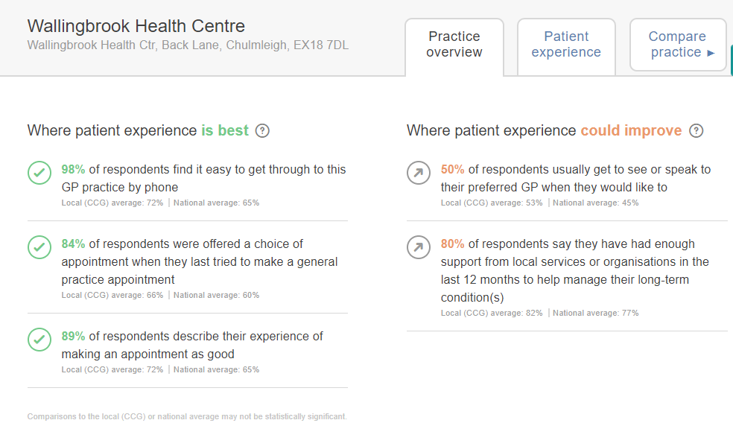  Mid Devon Healthcare Primary Care Network (PCN)  - First Contact Physiotherapy  The PCN has recently secured some First Contact Physiotherapy sessions; patients contacting the surgery with musculoskeletal problems can be booked into this service. The service is currently being delivered remotely but will be provided at each individual practice the future  eConsult – add that Practice does feedback to eConsult any feedback given from patients. eConsult has been built by gp’s and looked at improvements constantly.
5. | 2020 schedule  - Election of the Chair and Vice-Chair in accordance with Terms of Reference. (currently Jack Earnshaw & Jill Doe resp.)  Unable to vote for new Chair & Vice Chair as not a quorum of attendees, defer until September.  - Review Terms of Reference to reflect any changes in last year – no known changes needed  Set submission deadline for next newsletter.  The practice will plan to produce a newsletter for September; this would only be available as an eNewsletter. | JE  KB
6. | Wellness Activities – to note these are on-going topics  - Rural isolation  No update due to Covid-19  - Walking Groups  West Bank walking group has started again at Eggesford, under strict social distancing conditions, max of 5 walkers per walk leader. MS has not heard any updates from Barnstaple group.  - Self Care  No update due to Covid-19  - Continuity Counts  No update due to Covid-19
7. | Village Feedback from members  JE, SW & MS passed on their appreciation for the services the practice have provided during the pandemic, how safe patients have felt when they have attended the practice and the steps we have in place to ensure patient and staff safety.  Chulmleigh:  MS fed back a patient’s experience following their attendance to a MOB appointment.  The patient concerned wanted a MOB review ahead of time not realising that the service had been on hold during the pandemic and the team were attempting to undertake the backlog in date of birth order (i.e. the patients who had been seen over 12m away would be invited first).  When booking the appointment the patient was not informed they needed to bring a urine sample. LH explained normally the records would be reviewed in advance of the patient invite to ascertain what checks are required to avoid duplication and unnecessary recalls but due to the pandemic this work had not been undertaken as the July patients had not been called as yet.  The patient contacted the surgery to ask for paper copies of their recent blood test results, the Patient Services staff member noted the patient had online access and suggested they may be able to obtain access to their results via their online account. The patient’s feedback was they wished to have a paper copy so they could take notes in relation to their results when contacted by the practice and keep a record of events. The patient felt he really had to push to get a printout.  The patient fed back that the appointment reminder texts advise patients to read information regarding Coronavirus accessed via a link. Once patients click on the link the information provided is huge and it was fed back most patients would not have the time to read all the details. LH advised they are receiving lots of telephone requests for coronavirus information, providing the links gives the patient the opportunity to read the information should they wish.  LH advised the MOB process has been on hold during the pandemic and has only recently been reintroduced, and would refer the details raised back to the team.  The practice has been providing regular service updates via their website and Facebook page but appreciate that not all patients have IT access.  Additional information for the PPG on the MOB process:  To date the practice has not yet invited July patients for their MOB. This will happen in the next week or so.  Prior to the MOB process being activated a member of staff adds the details of which tests are required to a patients record (level setting) to avoid duplication of tests/checks.  Should a patient make a MOB appointment prior to receiving a text, phone call or letter MOB invite, the details of which tests would be required would not be available for a clinician.
8. | AOB – for information / to add to next agenda / urgent items  None to add
9. | Date of next meeting:  24 September at 2pm – in person or Zoom – will be confirmed nearer the time.

Patients are reminded that all questions and comments for the practice are welcome and details of Patient Participation Group members you are welcome to contact can be found at Chulmleigh and Winkleigh Surgeries. If you would like to discuss any matter with the practice directly please contact Lucy Harris the Practice Manager who will be pleased to make an appointment to discuss the matter in confidence.

